**Assignment: 8 (PHP + SQL)**

Database System & Web Lab (15B17CI372)

| INSTRUCTIONS  1. Upload your completed assignments on respective google classroom |
| --- |

1. Create a database testdb in my sql from php and then create a table student(Enrollment no, Name, Age, Course) and perform following operation.

(a) Insert the record for 10 students.

(b) Delete those student records who has age above 22.

(c ) perform update operation on atleast 2 rows.

(d ) display all the records after each operation.

1. Create a form to Add a new cupcake data into database with the mention validation constraints.

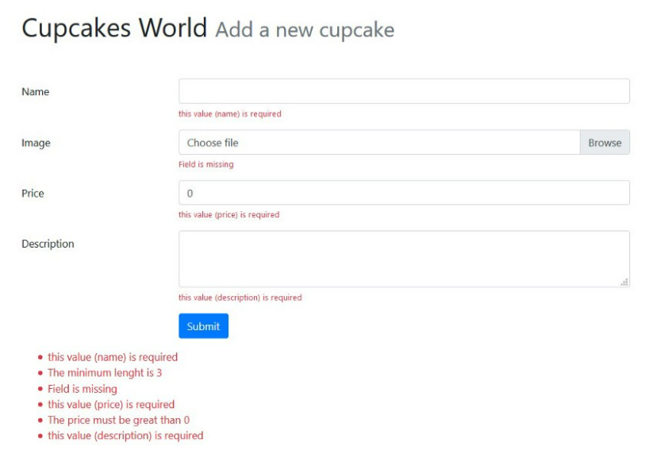

1. Design a database called employee, which contains information like empID, Name,department, branch, Salary, Gender. Design a web page which contains two textboxes in which user can input salary range. When user selects submit button, system should display:
   1. Details of all employees whose salary belongs to input range (ex 1000-10,000).
   2. List the highest salary profile of each category (male and female).
   3. Display all profiles in descending order according to emp name (whose name length is >4).
   4. Display the list of employees for each department in order of their salary.
2. There are two tables for Blood-donation camp site. Table 1 – list of donors, their addresses, their blood types and the names of the various blood-donation camps with which they are associated. Table 2 contains – the blood-donation camp's name, and the cities in which they have branches.

Create GUI, and using database connectivity, for a solving the following case: The user can select as many cities as he/she wants, using checkboxes. When user presses the “find” button on home.php, the system should display the list of donors, their blood types and the blood- donation camps which are existent in that particular city. Also, for a blood-type, find all the users in all the cities.

1. Write PHP script to design a web application which allows the registered user to see the list of music albums with the following details –album name, name of singer, music company, no of albums available and price of album. It also allows the user to sort the results by singer or price of album. Deign appropriate GUI Assume users are already registered.